Contact Information:  The study staff is here to help and support you at any time. Please contact us between visits for any of the following reasons:  - If you experience any discomfort that cannot be resolved or have any other medical problems  - If you cannot make your scheduled visit for any reason  - If your participation in the study causes problems with your partner, relatives, or other people or if they have any questions  - If you have questions about any of the information provided within this booklet  [site to insert contact information]  [Street Address]  [City, ST ZIP Code]  Phone: [Telephone]  Email: [Email address]  MTN-026 Information Booklet (v2.0_17July2017) |  |  | MTN-026  Important  Study Information Booklet

Important Information:  Researchers are conducting this study to see if an investigational drug called dapivirine is safe when used rectally. Dapivirine works to prevent HIV from making copies of itself, thus stopping the spread of HIV in the body. You will be asked to insert a gel containing either dapivirine or a placebo into your rectum approximately 8 times over the course of the study. First, study staff will administer a single dose of the gel. Then, following a minimum two-week washout period, you or study staff will administer daily rectal doses of study gel for 7 consecutive days under direct observation in the clinic. Researchers are also interested in learning more about how this study drug enters and exits the body.  Your participation is voluntary; you do not have to join or remain in the study if you do not want to.  You will have a total of 16 visits and one follow-up contact (by phone or in person). Most visits will last about [site to insert]. Some visits will last longer because you will be asked to provide samples of blood, rectal fluid and tissue. Women are also asked to provide vaginal fluid and cervical tissue.  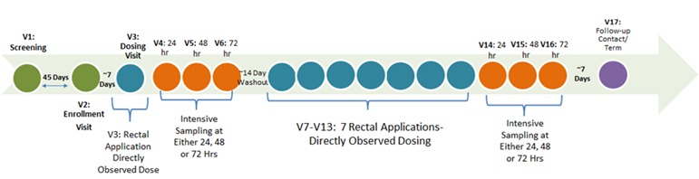  Study participation is expected to last 40 days. If you join, you will be randomly placed into 1 of 2 rectal gel study groups; one group will receive a placebo gel, which does not contain any study drug. The other group will receive gel containing dapivirine. No matter which group you are in, please remember that we do not know if this gel will protect you from getting HIV nor is this study testing whether the gel will prevent HIV. There are two known ways to prevent HIV: using condoms and/or an oral pre-exposure prophylaxis (PrEP). Study staff can tell you more about these options. |  |  | Prohibited Activities and Products:  You cannot join this study if you are currently or have recently taken part in another study of drugs, medical devices, genital and rectal products or vaccines. Please tell the study staff about studies you may have recently participated in, you are currently taking part in or are thinking of taking part in. You should also inform study staff of all medications you are taking or may take during the study. This is very important for your safety. Engaging in these practices or using any of the above products while in the study may make the gel work differently. These products and practices could irritate the rectum or vagina and increase the risk of side effects.  While in the study, you will be asked to avoid the following practices and medications for the entire duration of study participation:  - Using Heparin, including Lovenox®; Warfarin; Plavix®; hormone-replacement therapy (tablet, injectable or gel form); Aspirin (greater than 81mg); NSAIDS or any other drugs that increase the likelihood of bleeding; and CYP3A inhibitors and inducers (study staff will explain what these are in more detail)  All participants are asked to abstain from using rectal and/or vaginal non-study products 72 hours prior to each of your scheduled visits and during product use period.  Male participants are also asked to avoid the following sexual activities for 72 hours after biopsies are collected:  - Receptive sexual activity (anal sex, oral anogenital stimulation, rectal stimulation via fingers or the rectal use of sex toys)  Female participants are asked to avoid the following sexual activities for 7 days after biopsies are collected:  - Receptive anal intercourse, penile-vaginal intercourse, receptive oral anogenital stimulation, vaginal or rectal stimulation via fingers, and vaginal or rectal insertion of sex toys

